“TWO-er Duh Nord” 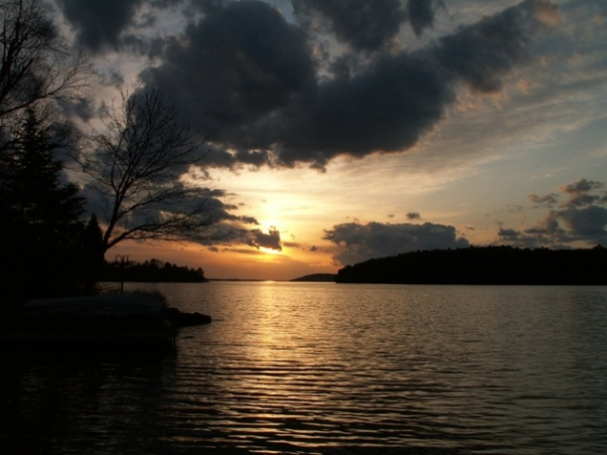

When ; June 23-25
Where ; Callander Ont
Tour ; Sat. A Northern Ontario driving tour starting on the shores of Lake Nipissing going along Hwy 654\522 through Commanda , Loring and Grundy Lake to Killarney Ont on the North Shore of Georgian Bay and then along the French River Hwy 64 to Sturgeon Falls back to North Bay. An Evening BBQ held at the Cooke’s on Trout Lake.
Sun. A drive along Hwy 63 to Temiscaming Que. for Sunday brunch at the Temrose followed by “twisted” drive along the Ottawa River to Mattawa Ont.
Sun. afternoon , All are invited back to Cooke’s (weather dependant) swim and relax till departure.
Accommodations; Terrace Suites in Callander Bay is offering a Queen Suite at a reduced group rate of $110.00 / night includes fridge,micro,kitchenette and fireplace. (queen room @ $100.) Call me to book room
Meals; Friday night – open but arrangements can be made for meal at hotel
Sat Morning – Timmies (we need an early start for a full day of driving\exploring)
Sat Lunch – Sportsman Lodge Killarney Ont shoreline restaurant
Sat Snack – Poutine in Sturgeon Falls
Sat Dinner – BBQ at the Cooke’s on Trout Lake (dinner will be a small contribution towards cost) & BYOB
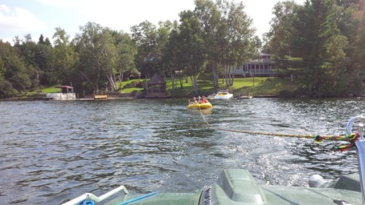
Sun Brunch – Temrose Rest. Temiscaming Que.
Websites; http://www.terracesuites.ca/
https://www.facebook.com/TerraceSuitesCallander/
http://sportsmansinn.ca/
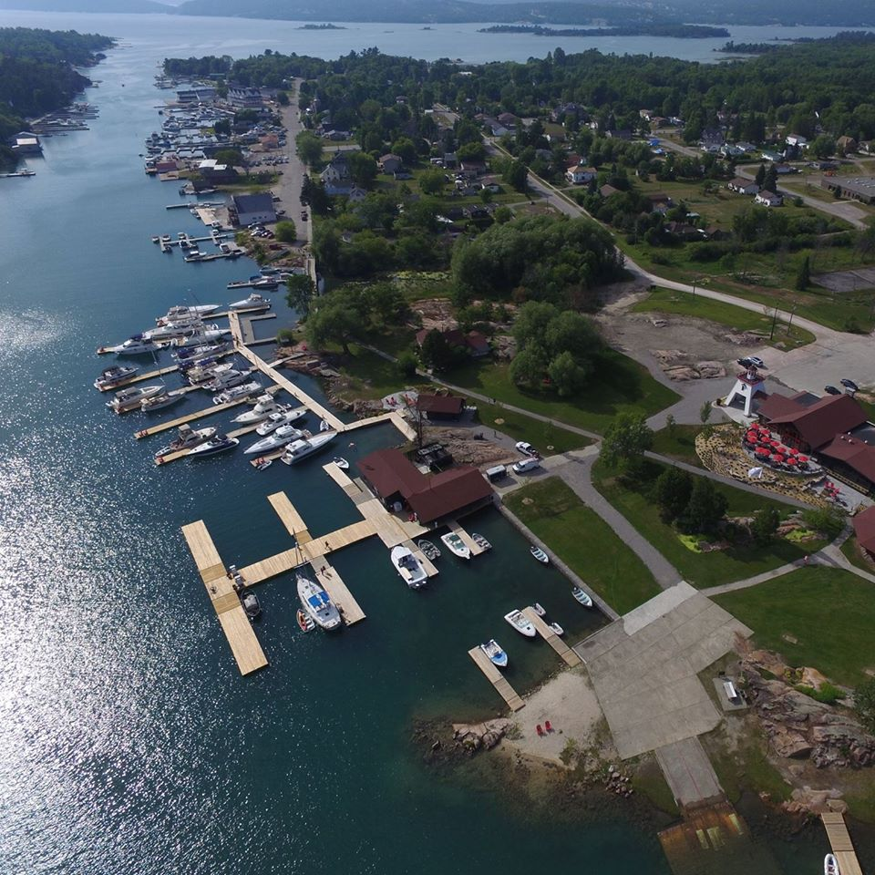

Reservations \ Questions ; Call Terry Cooke 705-471-4654 or 705-752-5533 Bookings will need to be done ASAP

