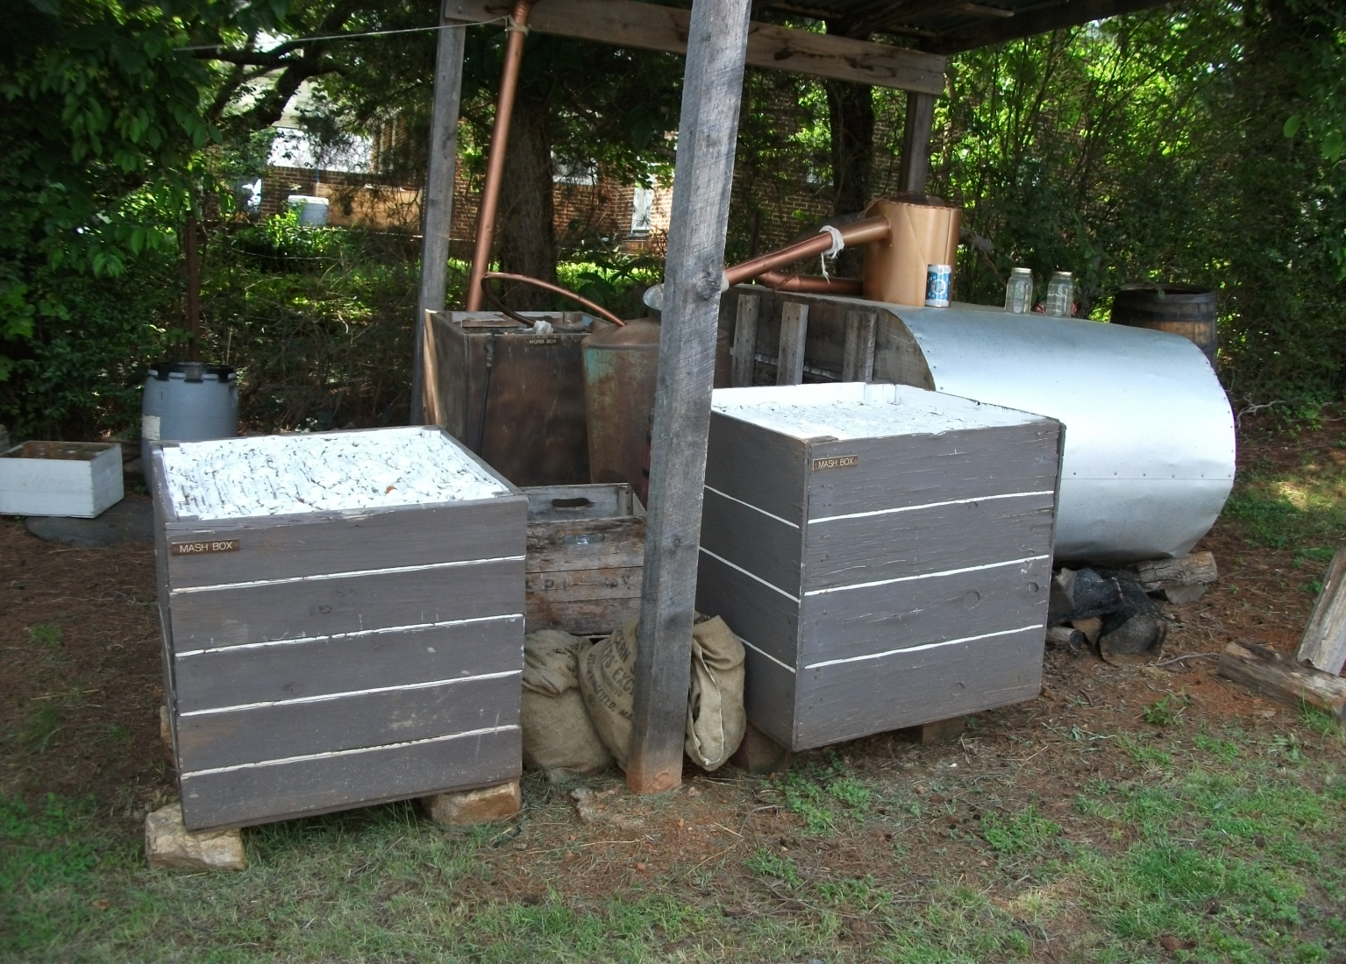
Crossfires
In
Moonshine Country
Third Annual
April 15 – 19, 2021
Mooresville, NC

